**Lab1 Assignment**

**Task1：**Register an account of the network drive supplied by the department of computer teaching in NPU. Master the basic operations of the network drive. The document [Network Drive Tutorial](Network%20Drive%20Tutorial.docx).docx will guide you.

**Task2：**View the file [Chapter1.pdf](2.MS%20Word%20Excercise/Chapter1.pdf), and then create a MS word document, which looks the same like the previous PDF file.

**Task3：**Complete the following programming projects.

1. Master the basic operations of the development environment of RAPTOR. The following instructions guide you how to use raptor.

* Insert a symbol into a program

Click a symbol, hold the mouse and move it, when reach the position where you want to place this symbol, release the mouse

* Delete a symbol from a program

Click the symbol which you want to delete, then right click and select the delete command. Or press the delete button on the keyboard to delete a symbol.

* Run a Raptor program

When you finish your raptor program, you can click the button  to run your program. Using this button , you can run your program one symbol by one symbol. We call it step by step running.

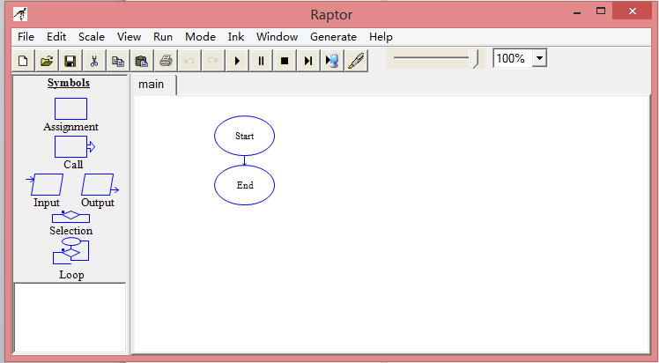

1. Create a simple raptor program named 1.1.rap

* New a RAPTOR file, give it a name “1.1.rap”
* Insert an output symbol into the flow chart

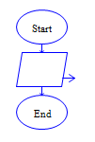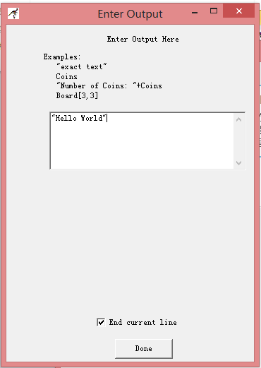

* Enter a string “Hello, world” in the Enter Output window.
* Use these running functions  to run this program.

1. Write a program: output a shape depicted as follows. Name your program file **1.2.rap**.



1. Write a program: Input two integer numbers, and output their summation.

For example, if the inputs are 2 and 3, the output should be “The sum is 5”.

Name your program file **1.3.rap**.

1. Write a program: input two numbers and use the variables x and y to record the values. Calculate x/y and then output the result. Name your program file **1.4.rap**.